**结合律Associativity 阿贝尔群Abelian group满足交换律Commutativity**

**Cr[a,b] Functions that are rtimes continuously differentiable**

**The sum of two subspaces U1 and U2​ is a direct sum if:** **Their intersection is the zero vector.** **Every element in the sum can be written uniquely as a sum of an element from U1 and an element from U2.**

**dimension of a vector space：All bases of a finite-dimensional vector space have the same number of vectors. It is the number of vectors in any basis.**

**Hamel basis: Subset B such that span(B) = V and B is linearly independent.**

**vector space over a field F: vector addition and scalar multiplication.**

**Group: associativity, identity, and inverse properties.**

**Injective: on to on, surjective: onto, bijective: both**

**(conf. transpose(A))ij​=Aji​  
It's absolute value represents the volume of the parallelotope formed by the column vectors of A. It's absolute value is the scaling factor for the volume of a region transformed by the matrix A.**

**If λλ is an eigenvalue. It can have many eigenvectors.**

**characteristic polynomial of a matrix A det(A - tI)**

**For a linear operator T and a vector v why are (v, Tv, T2v, …, Tnv) linearly dependent?** **It consists of (n+1) vectors in an n-dimensional vector space.**

**Which type of field guarantees that every operator has at least one eigenvalue? Complex field (C)**

**the trace of a matrix equal in terms of its characteristic polynomial The negative of the coefficient corresponding to the (n-1) degree term.**

**What is the eigenspace of an eigenvalue λ for an operator T? Ker(T - λI)**

**roots of the characteristic polynomial correspond to The eigenvalues of A.**

**Algebraic multiplicity. The multiplicity of the root λ in the characteristic polynomial.**

**geometric multiplicity. The dimension of the eigenspace E(λ,A).**

**trace of a matrix is independent on the choice of basis.**

**diagonalizable matrices: A diagonalizable matrix has the eigenvectors as its basis. The algebraic multiplicity of an eigenvalue must equal its geometric multiplicity for diagonalizability.**

**triangular matrices, excluding all zero-matrix: A triangular matrix always has its eigenvalues on the diagonal.** **Every square matrix is triangularizable over the complex numbers.** **A lower triangular matrix has elements above the diagonal equal to zero.**

**metric space: The distance must always be positive. The distance function must be symmetric. The triangle inequality must hold.**

**Cauchy sequences: Every convergent sequence is a Cauchy sequence. A Cauchy sequence must have bounded elements.** **A Cauchy sequence is one where the elements get arbitrarily close to each other as the sequence progresses.**

**Completeness: sequence converge, R is complete.**

**equivalence of norms: The norms induce the same topological properties, such as convergence of sequences.** **If two norms are equivalent, there exist constants α,β>0 such that α∣∣x∣∣a≤∣∣x∣∣b≤β∣∣x∣∣a*.***

**convex sets: If a set C is convex, then for any x,y∈C and b∈[0,1] , the point b⋅x+(1−b)⋅y is also in C. If a set is not convex, points x and y must exist a point on the line segment joining them lies outside the set.**

**unit ball: closed, convex, symmetric, have a non-empty interior.**

**Banach space: It is a complete metric space with respect to the metric induced by the norm.**

**completeness of function spaces: The space of continuously differentiable functions with the sup norm is not complete. The space of bounded continuous functions with the sup norm is complete. Completeness of a function space depends on the choice of norm.**

**Why is the space of continuously differentiable functions on [a,b][a,b] , denoted C1([a,b]), NOT a complete space (i.e., not a Banach space) when equipped with the supremum norm ∥f∥∞? A sequence of differentiable functions can converge (in the supremum norm) to a function that is not differentiable.**

**norm used to make this a Banach space? Cb(T) The supremum norm: ∥f∥∞​=sup t∈ T​∣f(t)∣**

**C1([*a*,*b*]): ∥*f*∥=∥*f*∥∞​+∥*f*′∥∞​ ∥*f*∥=∣*f*(*a*)∣+∥*f*′∥∞​  
inner product: Linearity in first argument, Symmetry, Positive definiteness.**

**relationship between inner products, norms, and metrics: Every inner product induces a norm via the formula ∥x∥=<x,x>. Every norm induces a metric via the formula d(x,y)=∥x−y∥.**

**orthonormal vectors: Each vector has norm 1.** **The dot product of any two distinct vectors in the set is zero. The vectors form a basis for the space they span.**

**Hilbert space: A complete inner product space.**

**subspace U of a pre-Hilbert space H, what does the orthogonal projection PU(w) represent?  vector in U that is 'closest' to w.** **A linear operator such that (PU)2=PU​. A vector such that w−PU​(w) is orthogonal to every vector in U.**

**If {v1​,...,vn}​is an orthogonal basis for a subspace U, what is the formula for the orthogonal projection of a vector w onto U?**

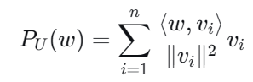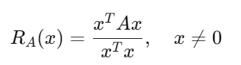 

**Q∈ Rnxn is called an orthogonal matrix：Its row vectors are orthonormal.**

**Its inverse is equal to its transpose ( Q−1=QT ).Its column vectors are orthonormal.**

**Orthogonal matrices represent transformations that have what geometric effect? They preserve the lengths of vectors ∥Qv∥=∥v∥ .They preserve the angles between vectors.**

**primary goal of the Gram-Schmidt orthogonalization: To transform a basis into an orthonormal basis for the same subspace.**

**Isometry: It preserves vector norms. It can be represented as a combination of rotations and reflections. It always corresponds to an orthogonal matrix in a Euclidean space.**

**A Hermitian matrix (A=A‾T). All eigenvalues of A are real. Its eigenvectors corresponding to distinct eigenvalues are orthogonal.**

**A self-adjoint operator on a pre-Hilbert space is one where ⟨Tv,w⟩=⟨v,Tw⟩ . How does this relate to matrices? A self-adjoint operator always has at least one real eigenvalue.On Rn with the standard dot product, a self-adjoint operator is represented by a symmetric matrix.On Cn with the standard inner product, a self-adjoint operator is represented by a Hermitian matrix.**

**any real symmetric matrix A can be diagonalized in There exists an orthogonal matrix Q and a diagonal matrix D such that A=QDQT.**

**positive definite (PD) matrices: A matrix A is PD if xTAx>0 for all nonzero xAll eigenvalues of a PD matrix are positiveA PD matrix is always invertible**

**A being positive definite (PD)** **The mapping <x,y>A=y‾TAx defines a valid inner product. All eigenvalues of A are non-negative .A can be written as a Gram matrix. The matrix A is invertible.**

**Gram matrix: It is positive definite (PD) if and only if the vectors {vi} are linearly independent. It is always symmetric (if the vectors are real) or Hermitian (if complex). It is always positive semi-definite (PSD).**

**Rayleigh quotient: The minimum value of the Rayleigh quotient is the smallest eigenvalue of A. The maximum value of the Rayleigh quotient is the largest eigenvalue of A. For symmetric matrices, the Rayleigh quotient can be negative.**

**square root of a symmetric PSD matrix A: here exists a symmetric, PSD matrix B such that A=B2.**

**Min–Max: The minimum and maxmum eigenvalue of A can be obtained by minimizing the Rayleigh quotient. The Min–Max Theorem provides a method for estimating eigenvalues without explicitly computing them.**

**Singular Value Decomposition (SVD): Every matrix has an SVD decomposition.** **The singular values of a matrix are always non-negative.**

**How are the singular values and singular vectors of a matrix A related to the eigenvalues and eigenvectors of other matrices? The left singular vectors of A (columns of U) are the eigenvectors of AAT. If A is symmetric, its singular values are the absolute values of its eigenvalues.** **The right singular vectors of A (columns of V) are the eigenvectors of ATA.**

**singular values: singular values of A and AT are same. singular values of A do not change if we multiply A by an orthogonal matrix. If A is symmetric and semi-positive definite, its singular values are equal to eigenvalues.**

**The key difference between SVD and Eigendecomposition is: SVD always exists, but Eigendecomposition does not.** **The singular values of a matrix are always real and non-negative, whereas eigenvalues can be complex.For a symmetric matrix, SVD and Eigendecomposition are nearly the same.**

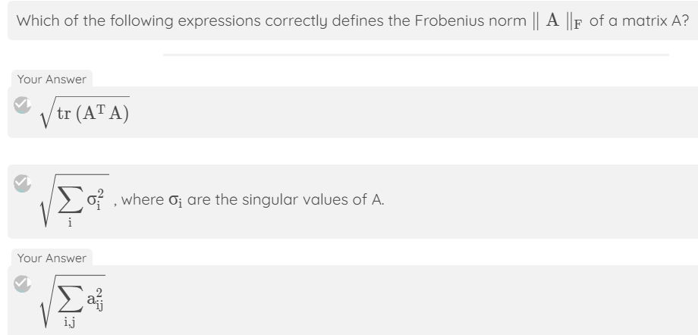

**The operator norm/spectral norm of a matrix A is: The largest singular value of A.**

**Given the SVD of a matrix A, the best rank-k approximation, Ak: where the singular values are sorted in descending order.**

**秩 k SVD 近似 Ak*Ak*​ 在哪些范数下是最优：spectral norm ( ∥A−Ak∥2is minimized).The Frobenius norm ( ∥A−Ak∥F ​ ​ is minimized).**

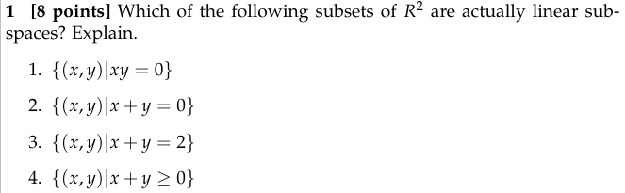

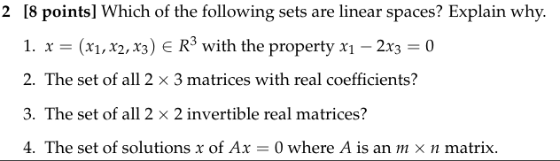

**{x∈ℝ³|x₁-2x₃=0}: ✅ Linear space (solution space of homogeneous equation).**

**All 2×3 matrices: ✅ Linear space (satisfies all vector space axioms).**

**All 2×2 invertible matrices: ❌ Not a linear space (no zero matrix, not closed under addition).**

**Solutions of Ax=0: ✅ Linear space (null space is always a subspace).**

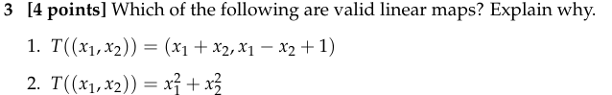

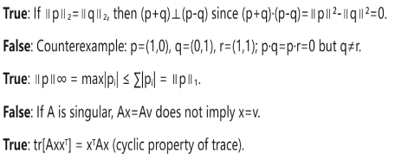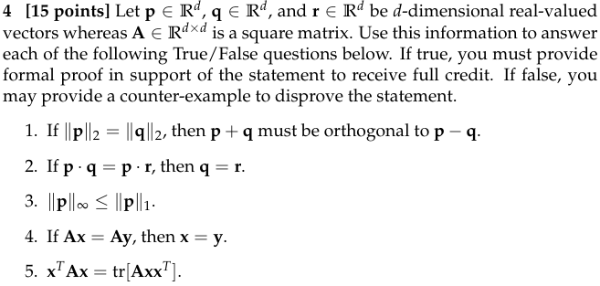

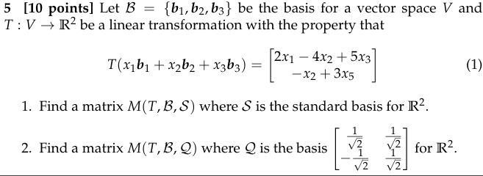

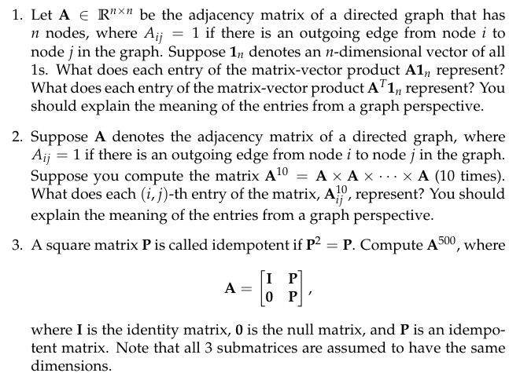

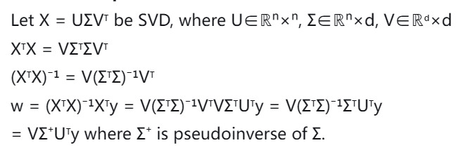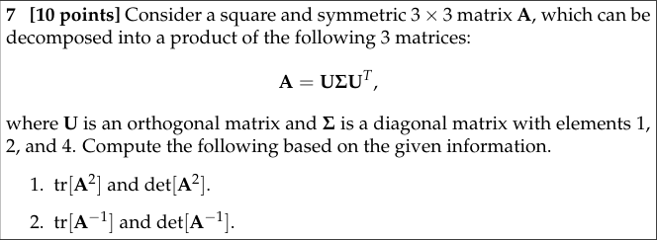

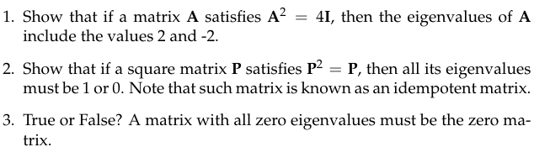

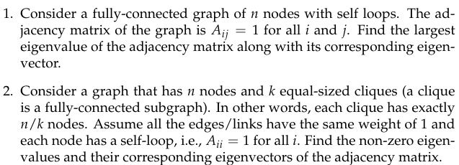

**k cliques of size n/k: Non-zero eigenvalues = n/k (multiplicity k), eigenvectors = indicator vectors for each clique.**

